**ONLINE STORE (**E-COMMERCE**)**

**T. TARUN KUMAR**

**REQUIREMENTS**

Designing a website involves several key requirements to ensure its effectiveness and user-friendliness. Here are some important requirements to consider:

* Responsive Design
* Visual Appeal
* Content Organization
* Consistency
* Loading Speed
* Accessibility
* Security

Remember that these requirements may vary depending on the specific nature of the website and its intended purpose. It's essential to keep up with current design trends, technologies, and best practices to create an effective and successful website.

**FUNCTIONALITIES**

When designing a website, you'll need to consider various functionalities to ensure it meets the needs of your audience and achieves its intended goals. Here are some important functionalities to consider:

* Responsive Design
* Navigation Menu
* Search Functionality
* User Login
* Content Management System (CMS)
* Blog or News Section
* Analytics and Tracking
* Security Measures

Remember, the specific functionalities you choose will depend on the nature of your website and its goals. Prioritize features that align with your target audience's needs and enhance the overall user experience.

**OBJECTIVES**

The goal of web design for an online business is to develop a captivating, intuitive, and aesthetically pleasing website that successfully shows goods or services and improves the user experience as a whole. The following succinct statement sums up the main goals:

* Enhance User Experience.
* Increase Conversion Rates.
* Showcase Products or Services.
* Optimize For Mobile Device.
* Foster Brand Consistency.
* Enabling Scalability and Flexibility.

By focusing on these Objectives, I am going to create an online store website that engages users, drives conversions, build trust and ultimately contributes to the success of the e-commerce business.

**DESIGN INSPIRATION**

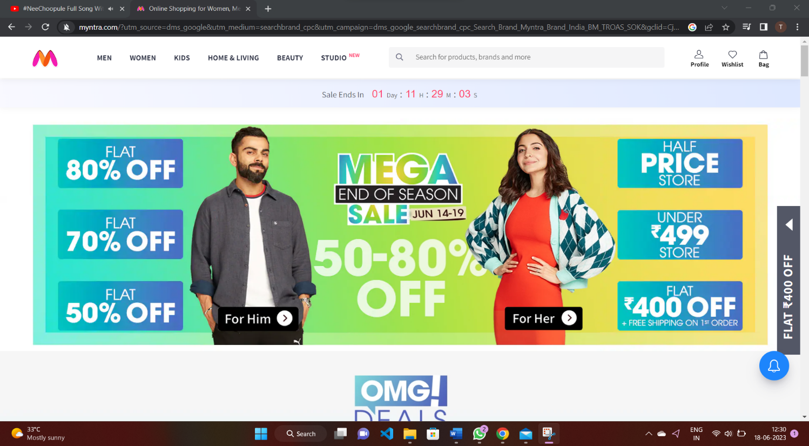

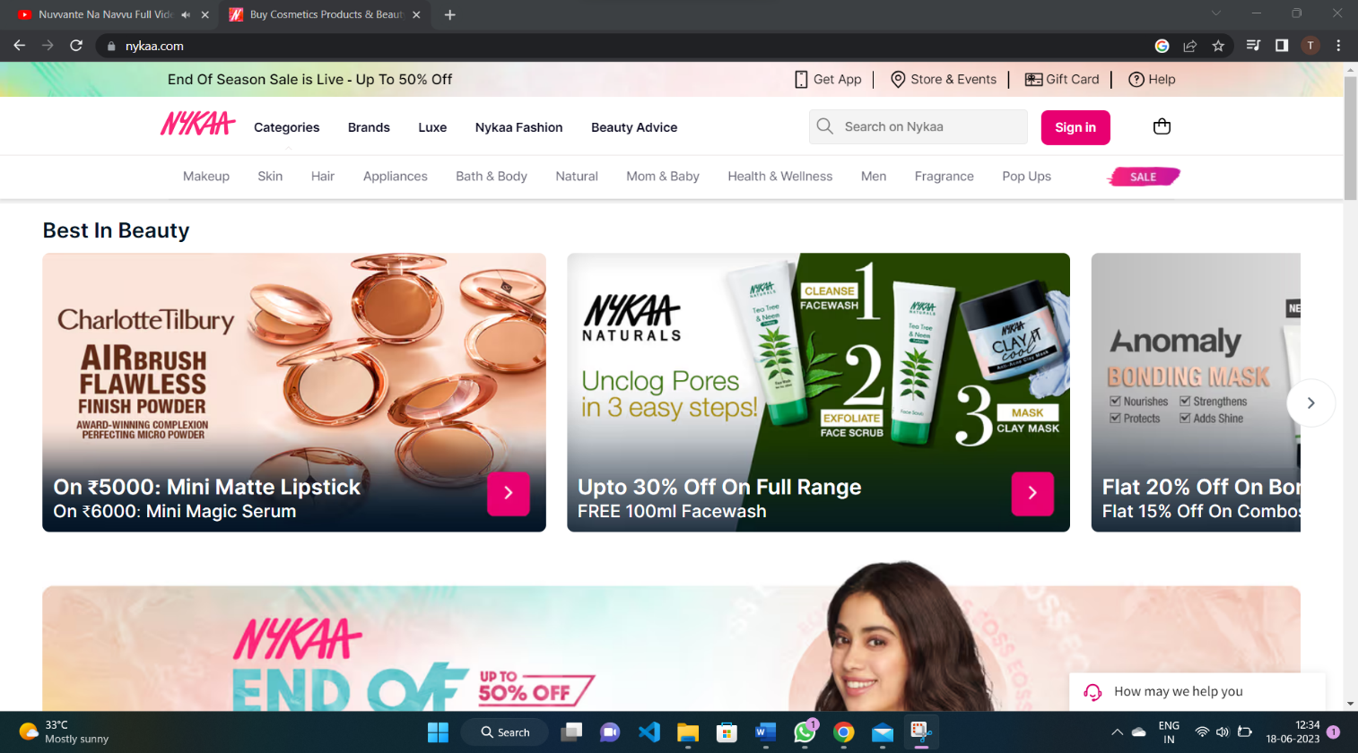

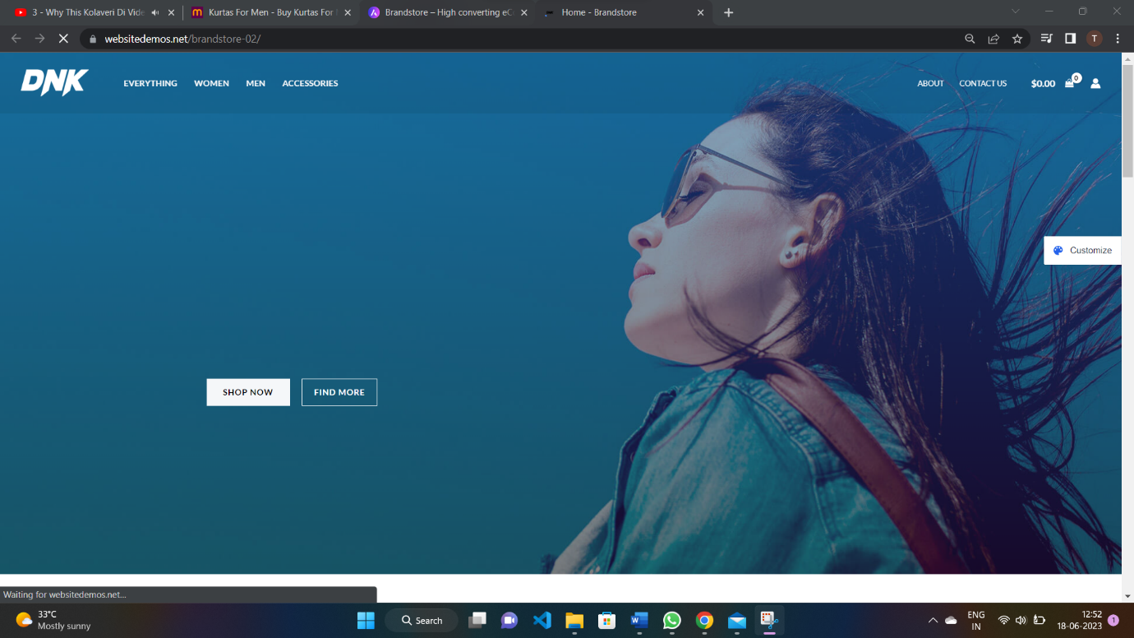

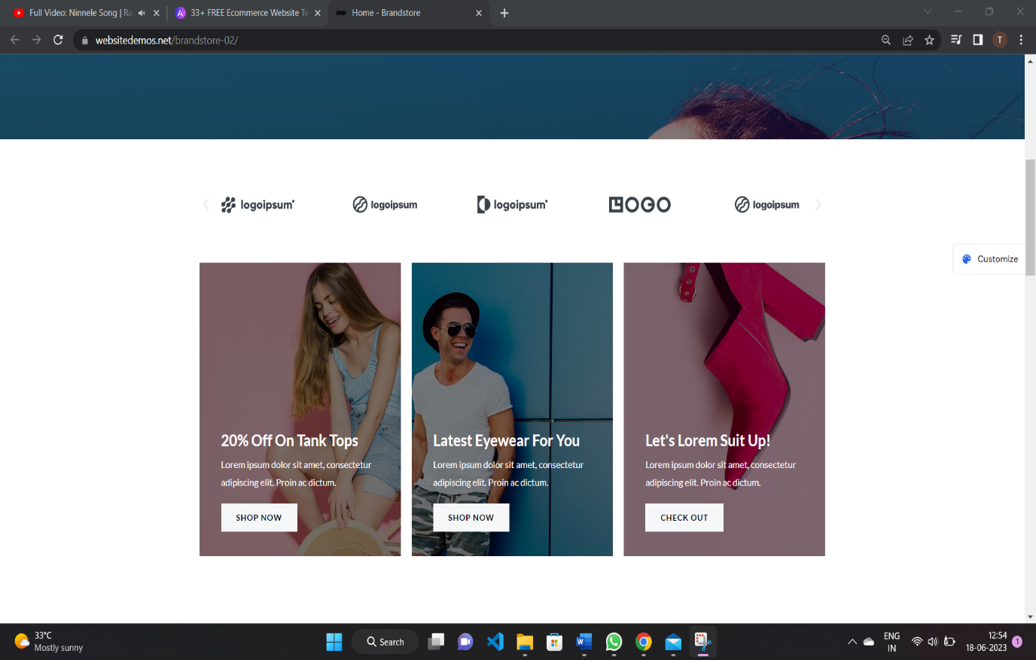

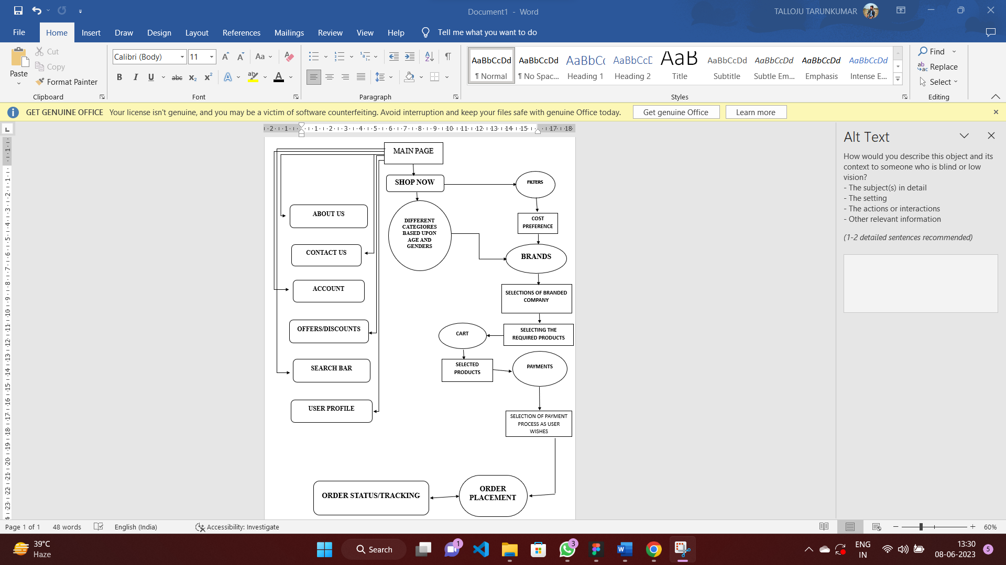**SKETCH INTITIAL WIREFRAMES**

**ABOUT US:**

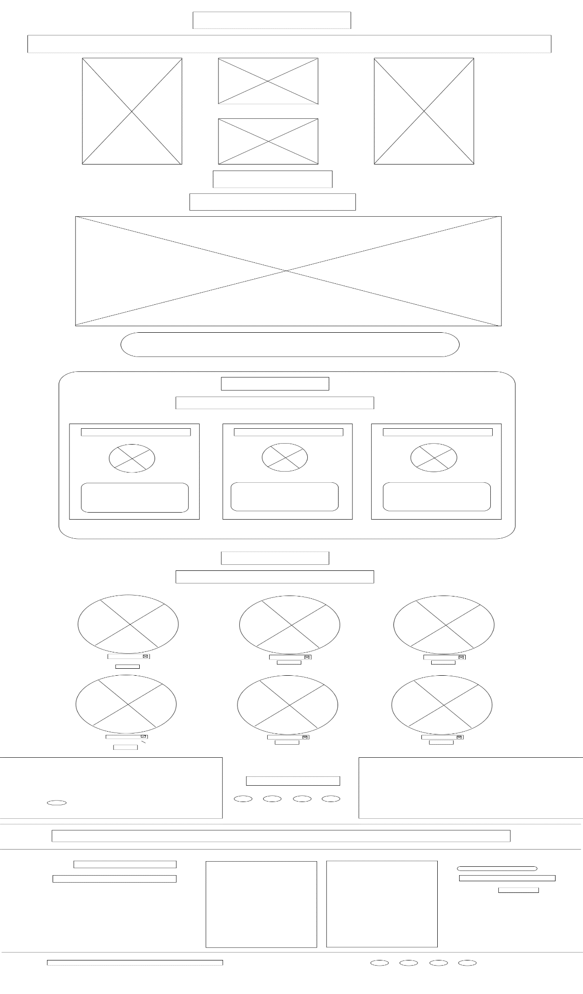

**ACCOUNT:**

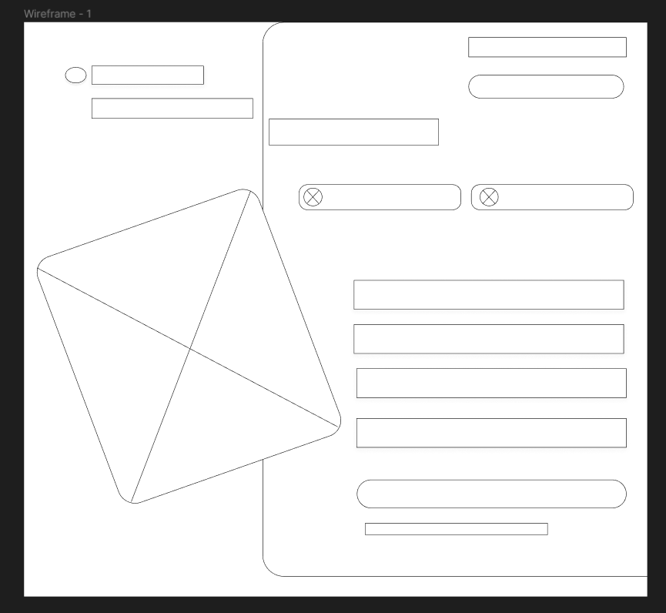

**PROFILE:**

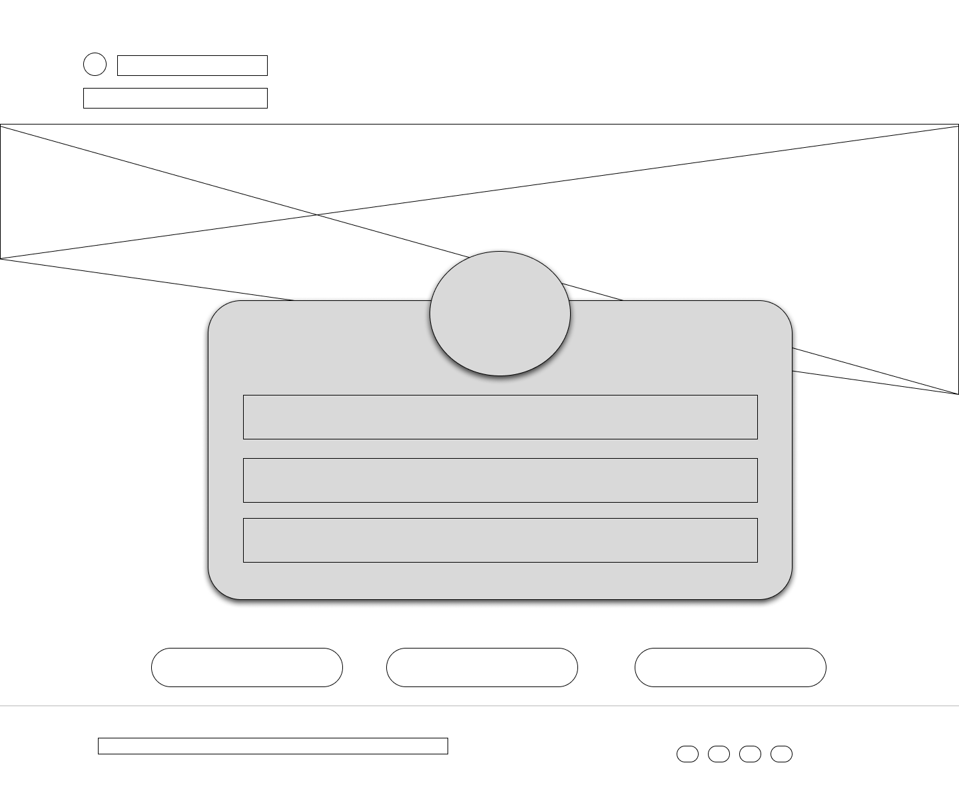

**CONTACT US:**

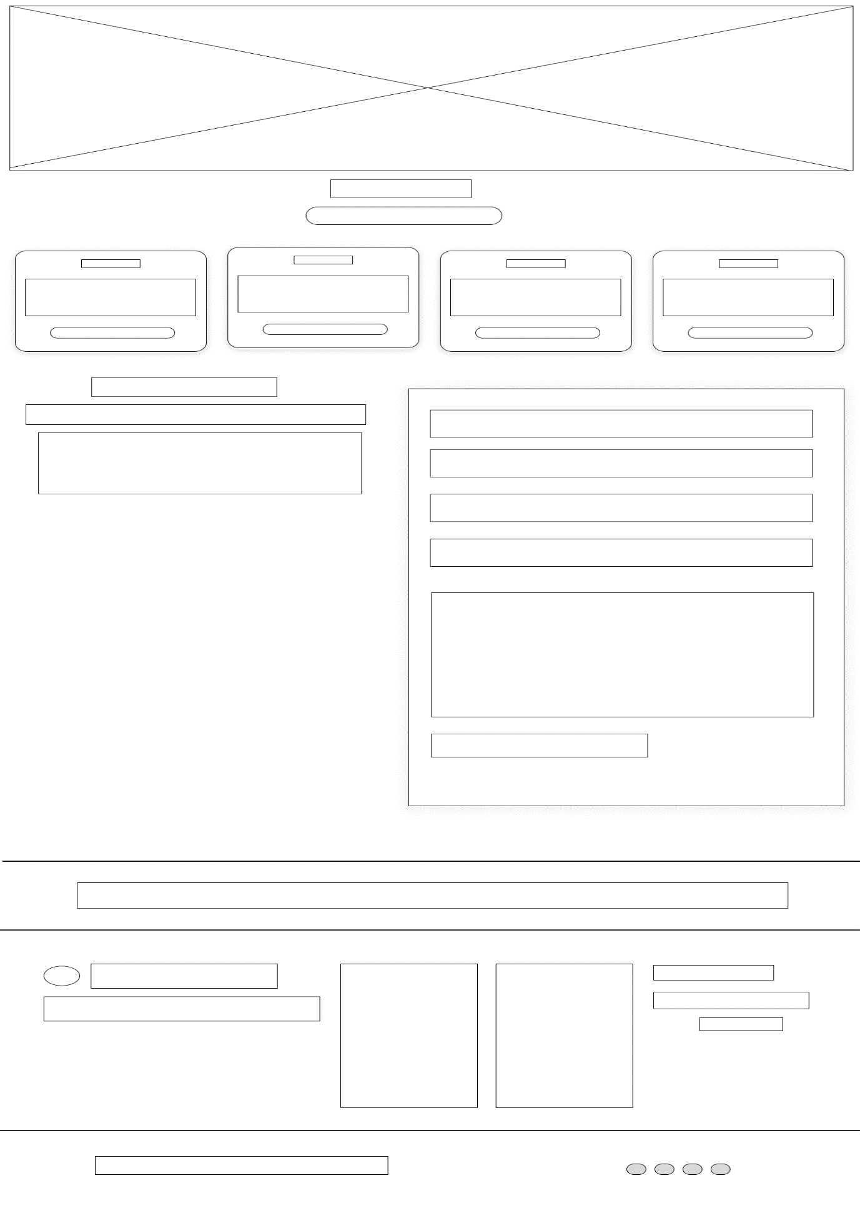

**OFFERS:**

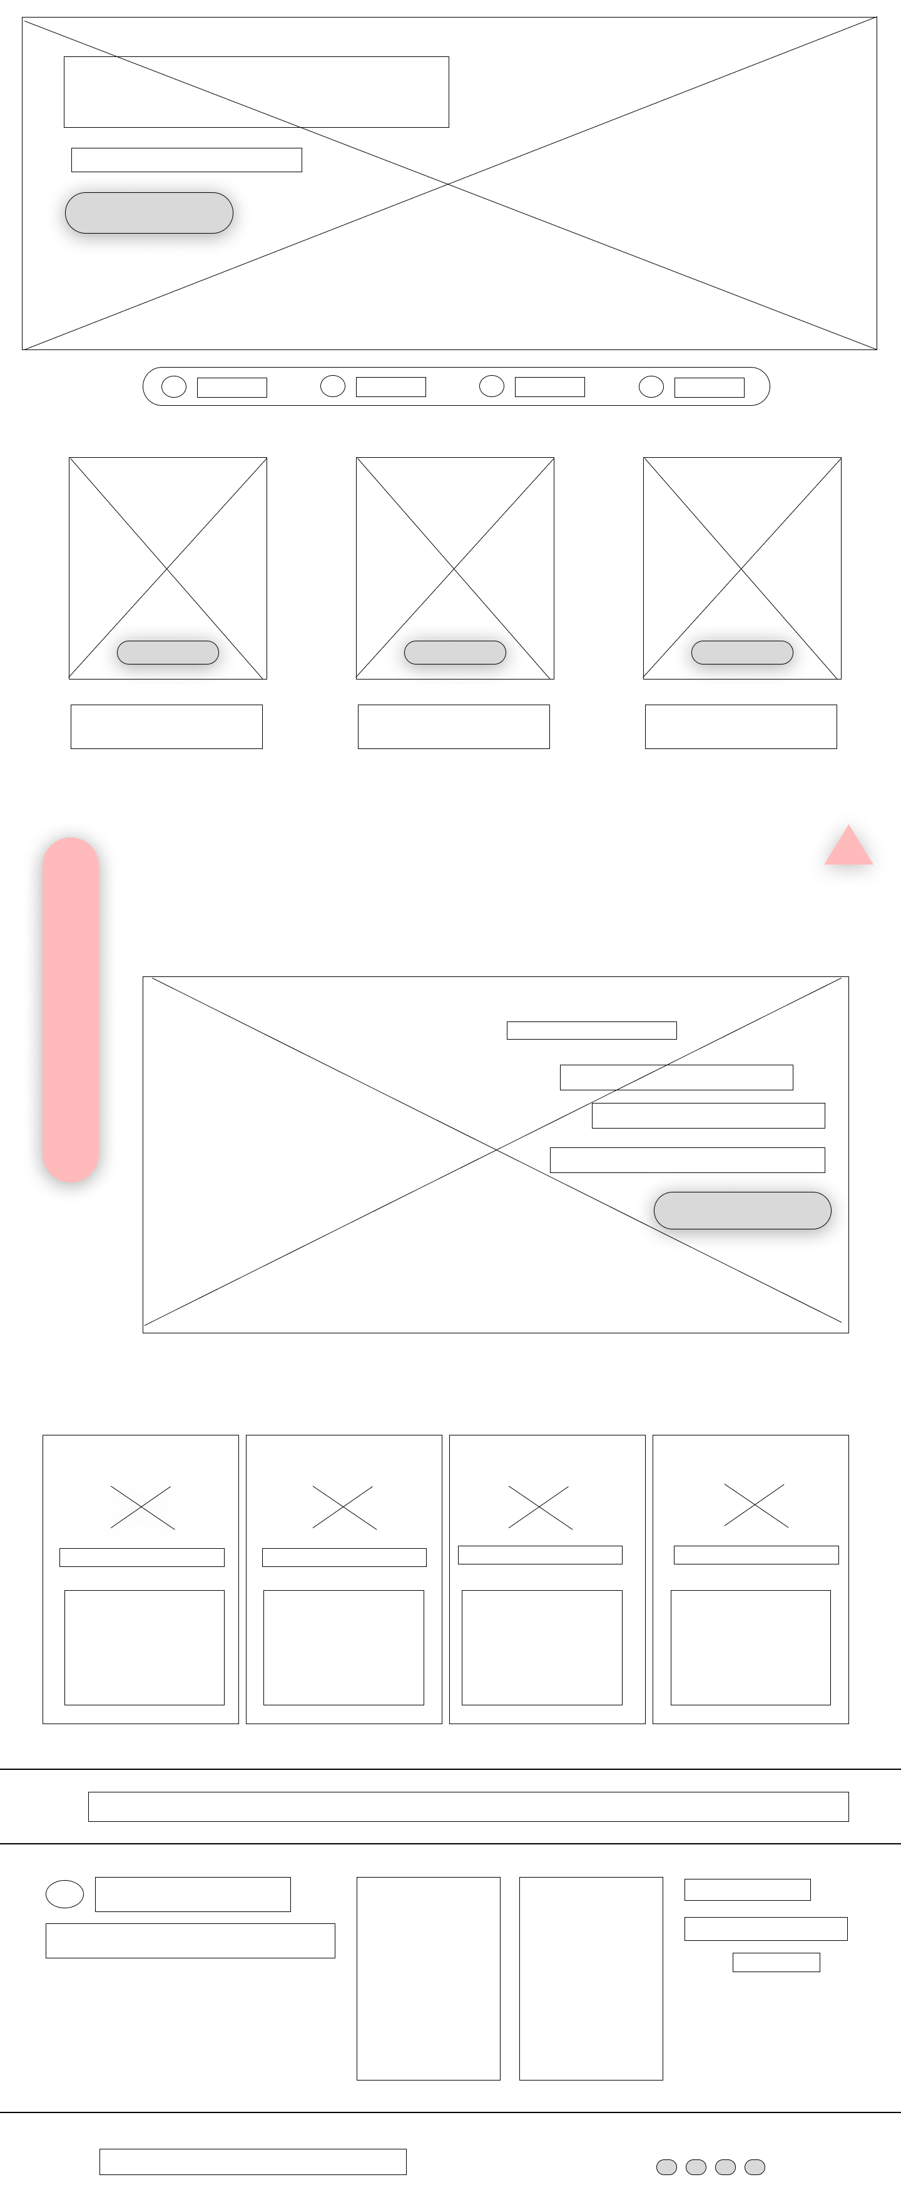

**SHOP NOW:**

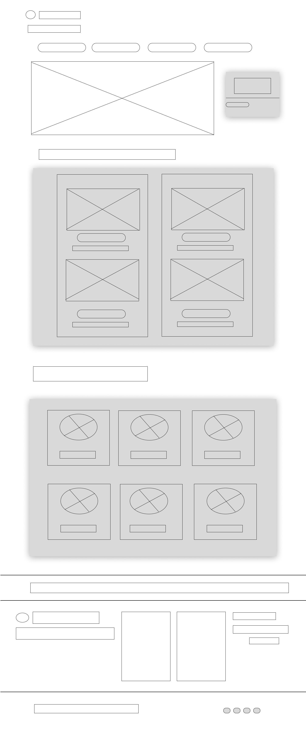

**DIGITAL WIREFRAMES**

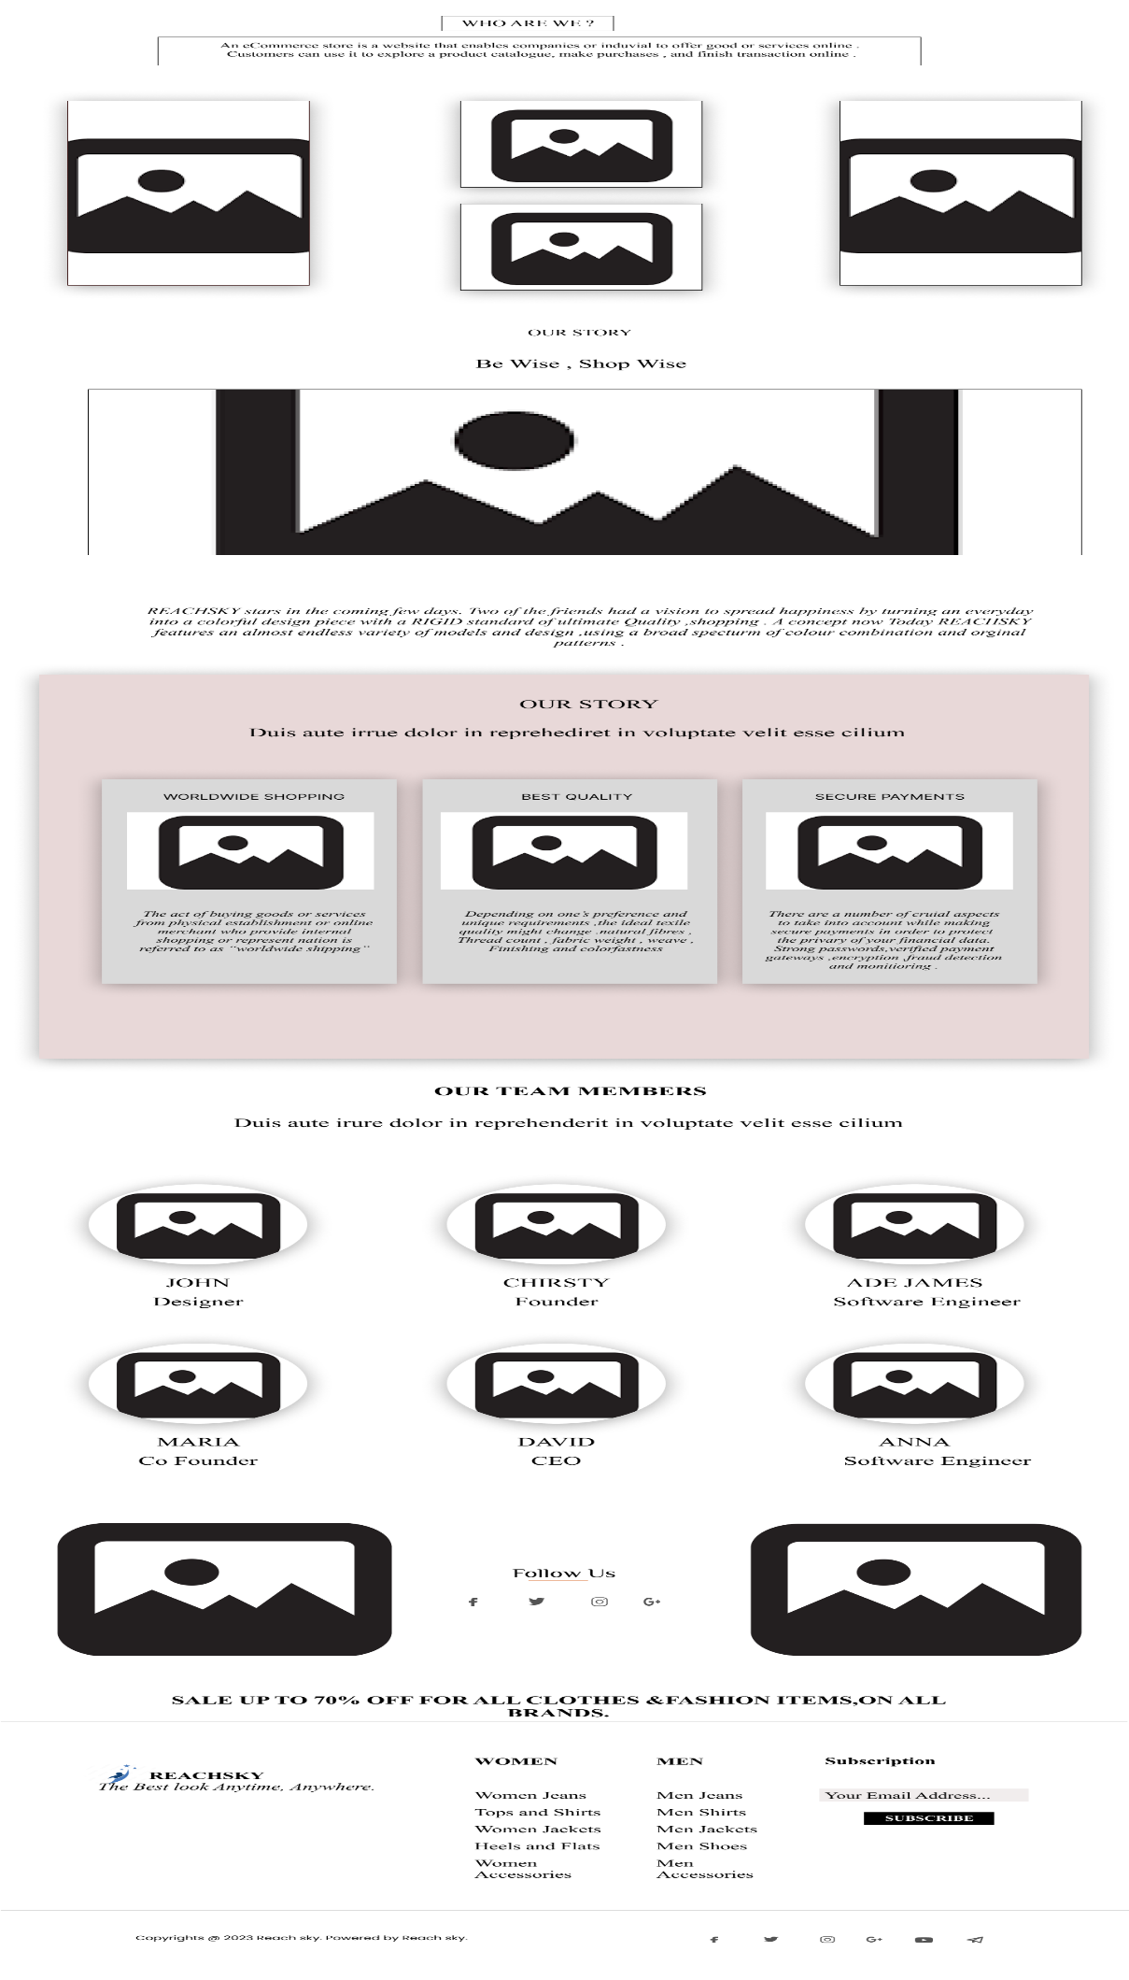**ABOUT US:**

**CONTACT US:**

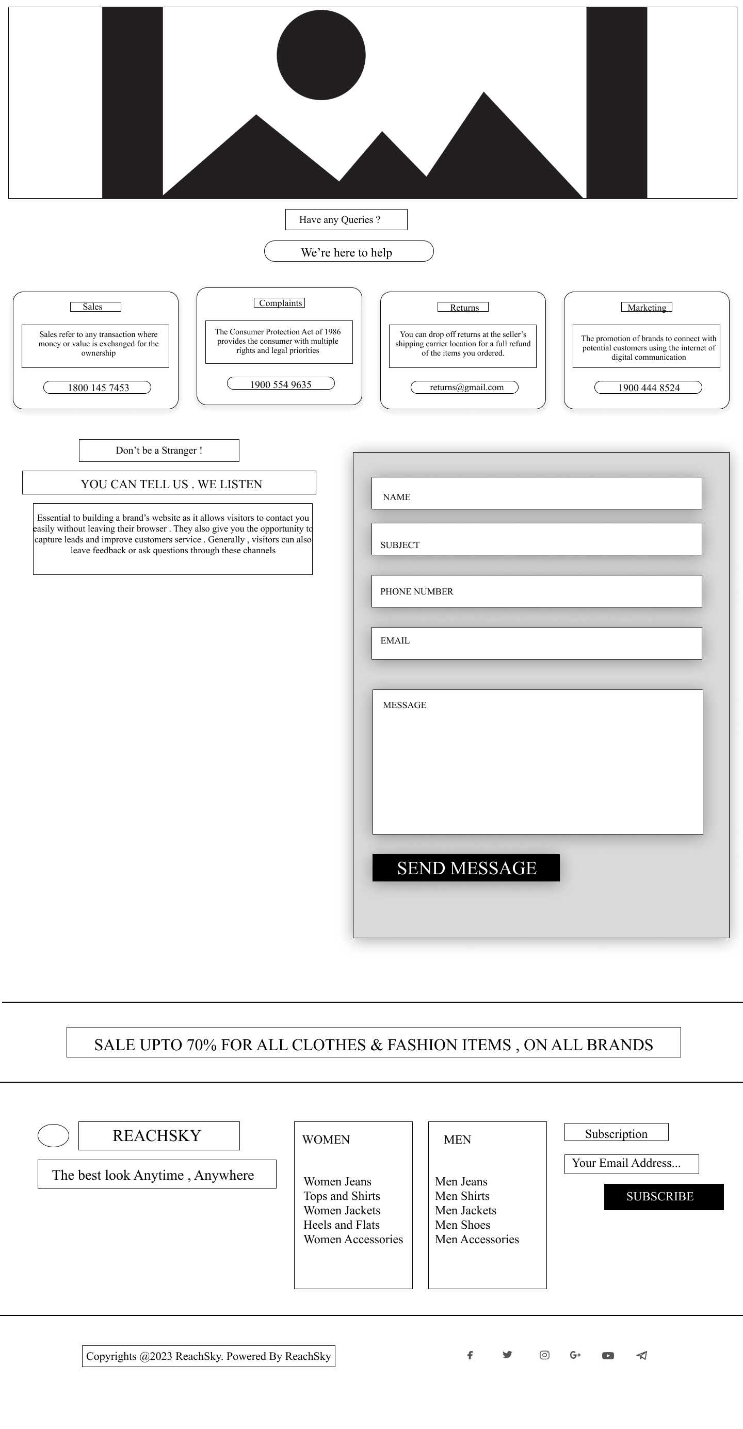

**ACCOUNT:**

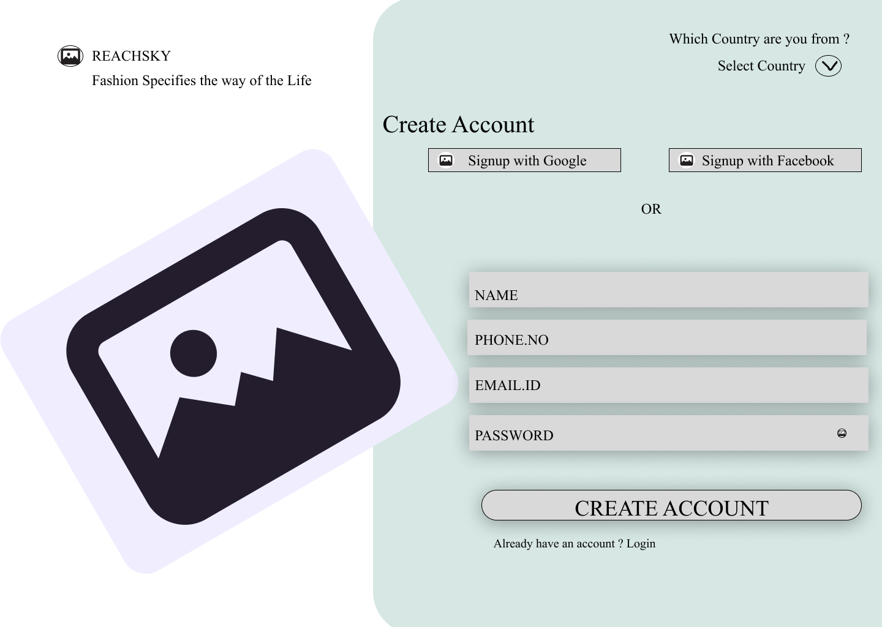

**PROFILE:**

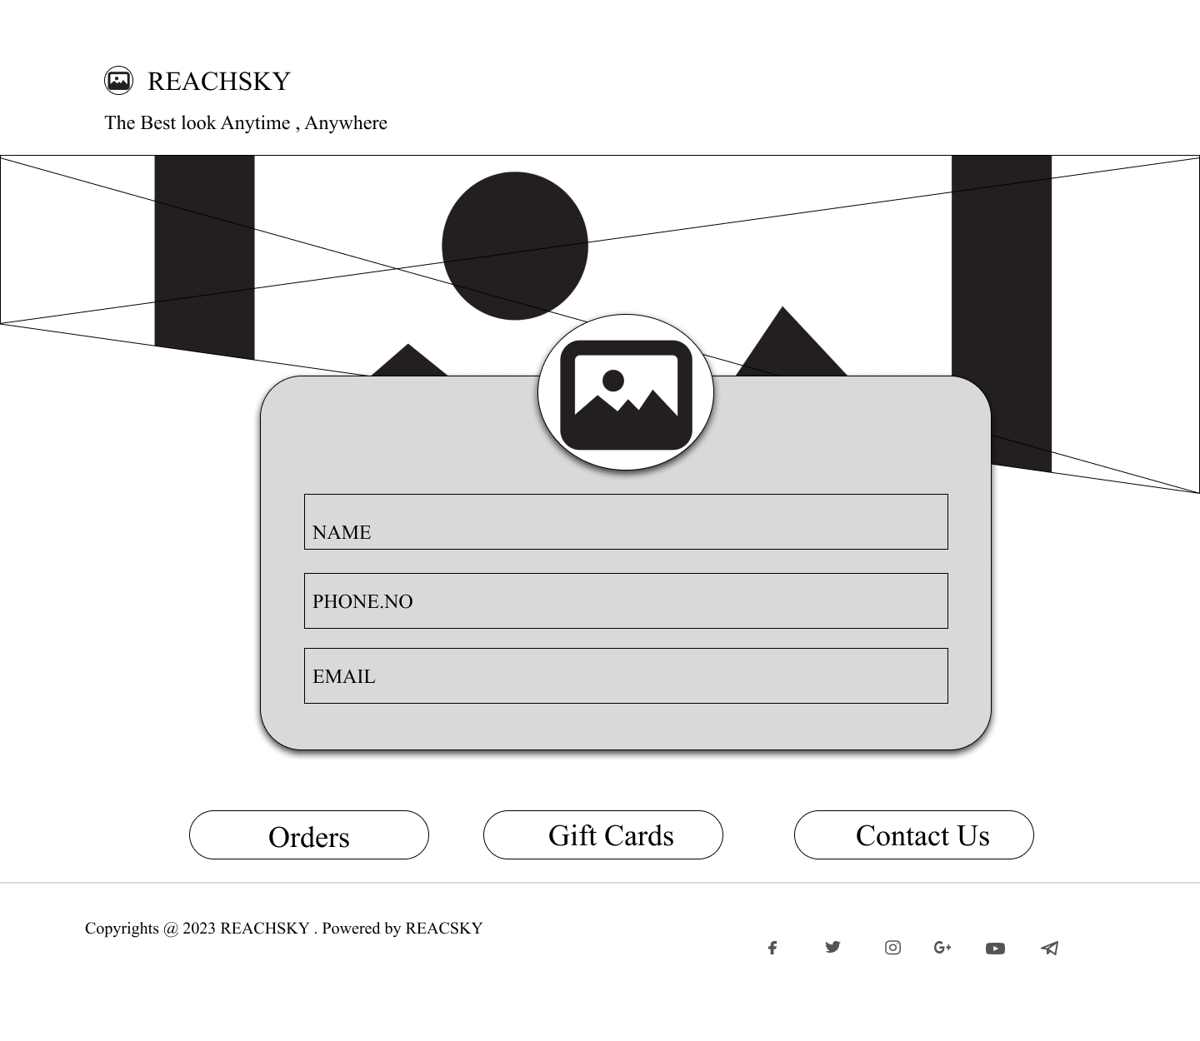

**OFFERS:**

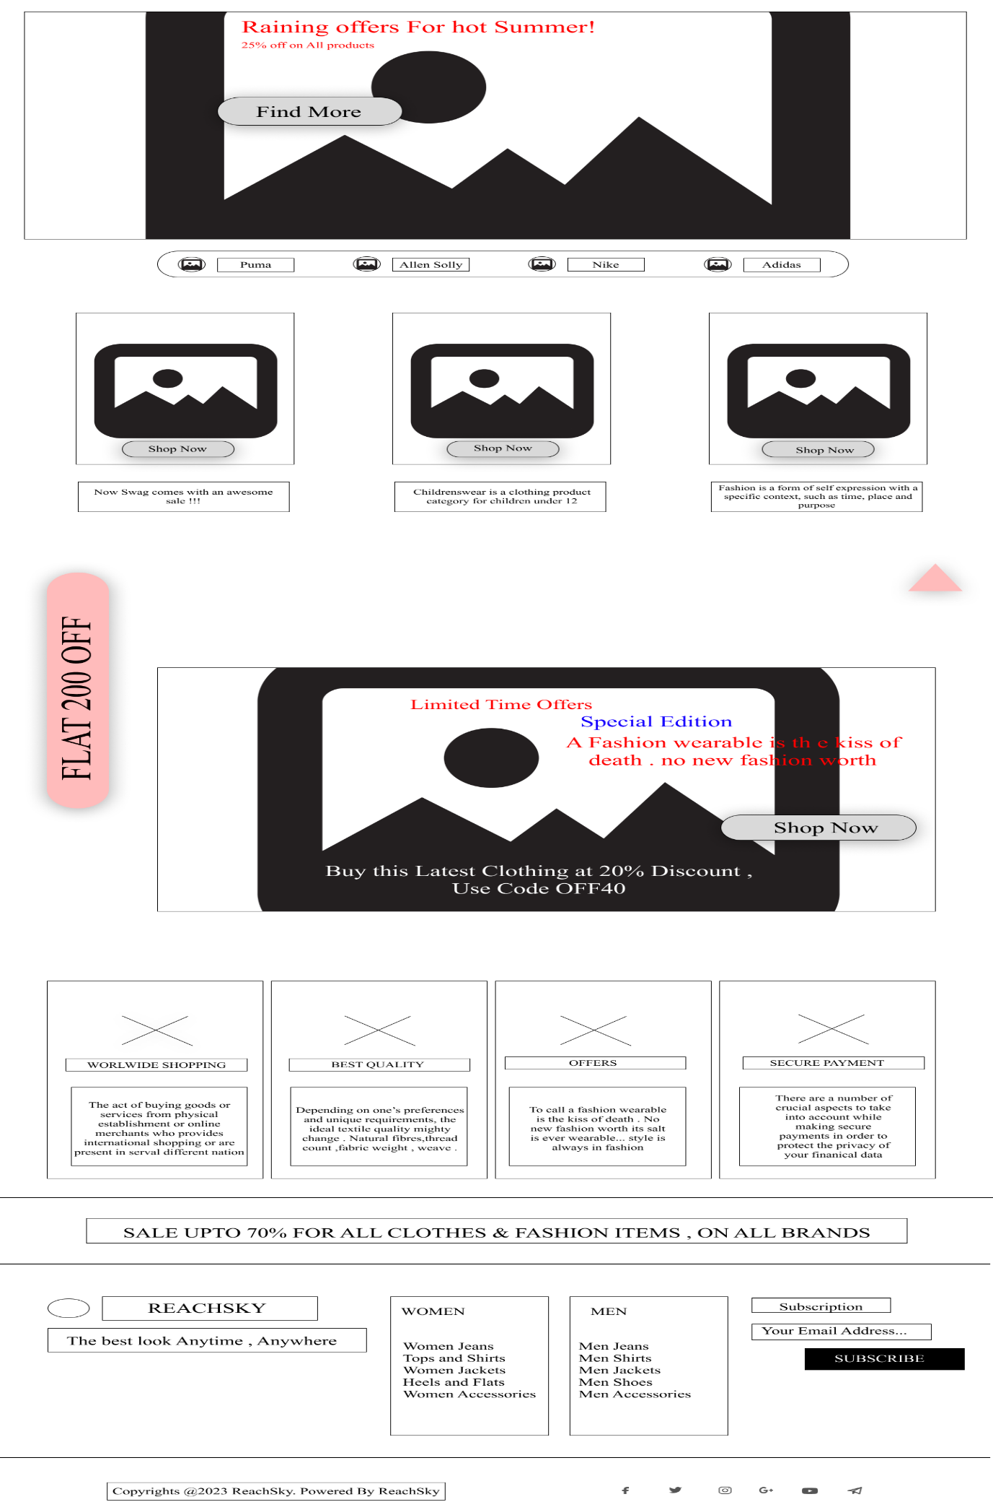

**SHOP NOW:**

